SMART DIGITAL THERMOSTAT CIRCUIT DIAGRAM
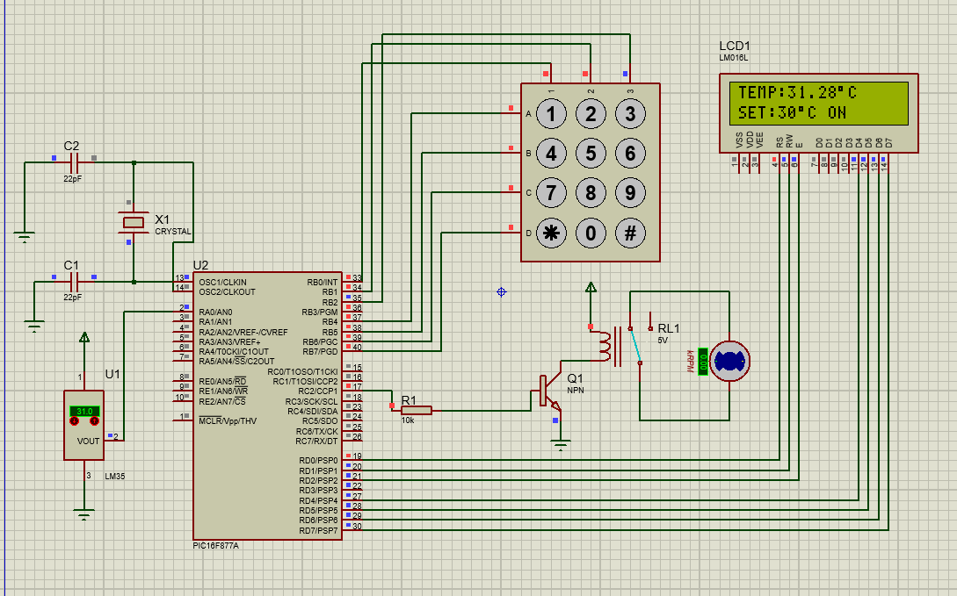

DIGITAL PASSWORD DOOR LOCK
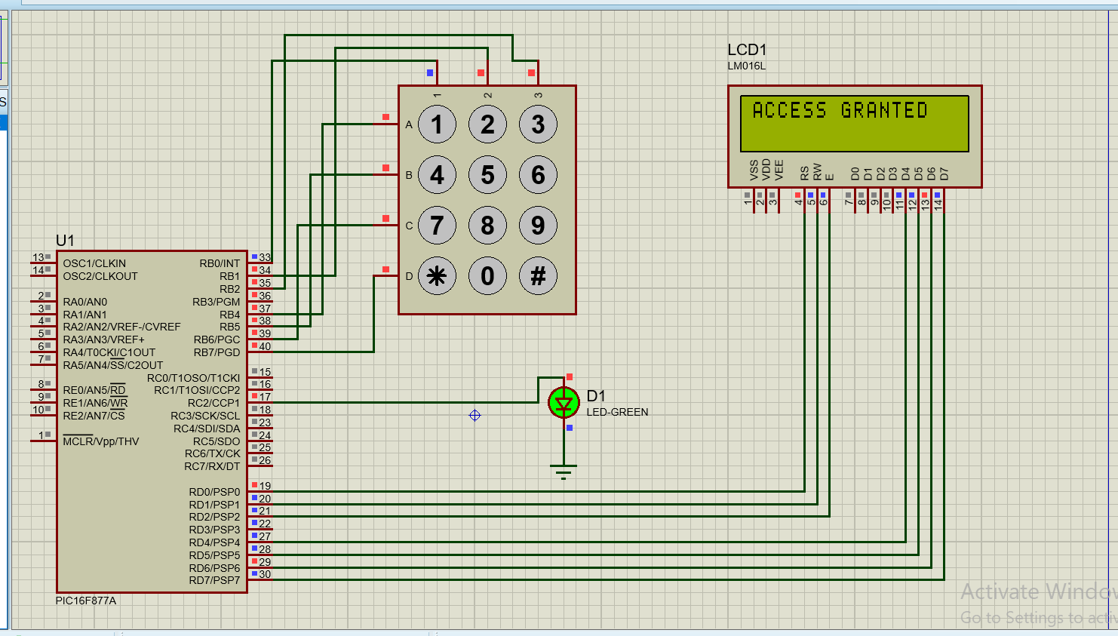
SMART PARKING COUNTER SYSTEM
